1-Network Interface Card (NIC)

🧩 What is a Network Interface Card (NIC)?
# Source: Chatgpt (GPT‑5 Mini) at [12/18/2025]
A Network Interface Card (NIC) is a hardware component—either built-in or installed—that allows a computer, server, or other device to connect to a network (like a LAN or the internet). It handles sending and receiving data over the network using specific communication standards (like Ethernet or Wi-Fi).
✅ Think of a NIC as the network “port” of your computer — it gives your device a unique address (MAC address) and connects it to the rest of the world.

🔌 Where It’s Used
# Source: Chatgpt (GPT‑5 Mini) at [12/18/2025]
- Desktops and laptops (Ethernet or Wi-Fi NIC)
- Servers in data centers (often with high-speed NICs)
- Routers, firewalls, switches (for communication between ports)
- Virtual machines (virtual NICs)

🔧 NIC Functions
# Source: Chatgpt (GPT‑5 Mini) at [12/18/2025]
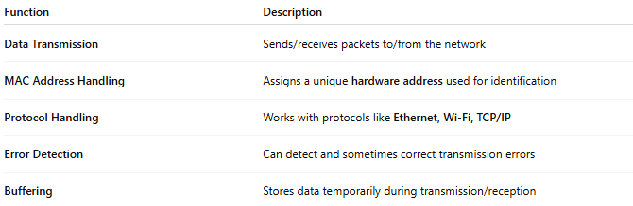
Function | Description
Data Transmission | Sends/receives packets to/from the network
MAC Address Handling | Assigns a unique hardware address used for identification
Protocol Handling | Works with protocols like Ethernet, Wi-Fi, TCP/IP
Error Detection | Can detect and sometimes correct transmission errors
Buffering | Stores data temporarily during transmission/reception

🧠 Types of NICs
# Source: Chatgpt (GPT‑5 Mini) at [12/18/2025]
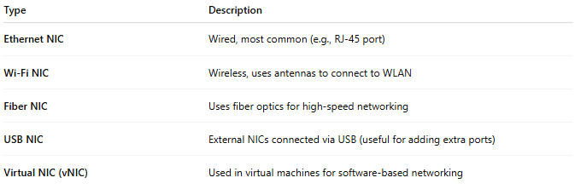
Type | Description
Ethernet NIC | Wired, most common (e.g., RJ-45 port)
Wi-Fi NIC | Wireless, uses antennas to connect to WLAN
Fiber NIC | Uses fiber optics for high-speed networking
USB NIC | External NICs connected via USB (useful for adding extra ports)
Virtual NIC (vNIC) | Used in virtual machines for software-based networking

🔄 NIC in Action (Simple Diagram)
# Source: Chatgpt (GPT‑5 Mini) at [12/18/2025]
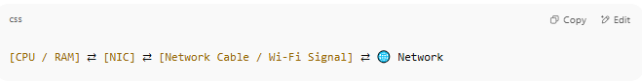
[CPU / RAM] ⇄ [NIC] ⇄ [Network Cable / Wi-Fi Signal] ⇄ 🌐 Network

- NIC communicates between your computer’s internal bus and the external network.

🔍 Example Specs You Might See
# Source: Chatgpt (GPT‑5 Mini) at [12/18/2025]
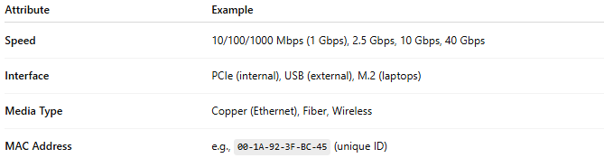
Attribute | Example
Speed | 10/100/1000 Mbps (1 Gbps), 2.5 Gbps, 10 Gbps, 40 Gbps
Interface | PCIe (internal), USB (external), M.2 (laptops)
Media Type | Copper (Ethernet), Fiber, Wireless
MAC Address | e.g., 00-1A-92-3F-BC-45 (unique ID)

✅ Advantages
# Source: Chatgpt (GPT‑5 Mini) at [12/18/2025]
- ✅ Enables all network connectivity (wired/wireless)
- ✅ Can upgrade network speed with a better NIC
- ✅ Can be virtualized for cloud or VM environments

❌ Disadvantages
# Source: Chatgpt (GPT‑5 Mini) at [12/18/2025]
- ❌ Faulty NIC can cause loss of connectivity
- ❌ Needs drivers/software to work properly
- ❌ Limited by physical medium (e.g., no Wi-Fi on Ethernet-only NIC)

📌 Summary
# Source: Chatgpt (GPT‑5 Mini) at [12/18/2025]
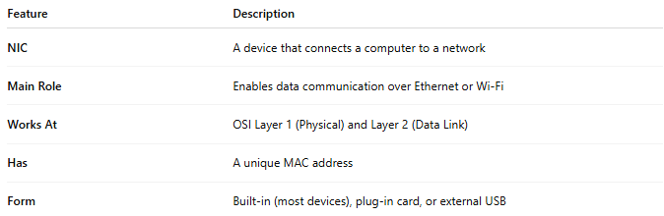
Feature | Description
NIC | A device that connects a computer to a network
Main Role | Enables data communication over Ethernet or Wi-Fi
Works At | OSI Layer 1 (Physical) and Layer 2 (Data Link)
Has | A unique MAC address
Form | Built-in (most devices), plug-in card, or external USB

2-MAC address

🆔 What Is a MAC Address?
# Source: Chatgpt (GPT‑5 Mini) at [12/18/2025]
A MAC address (Media Access Control address) is a unique hardware identifier assigned to a network interface card (NIC) for communication on a local network (like Wi-Fi or Ethernet).

🧠 Simple Definition:
# Source: Chatgpt (GPT‑5 Mini) at [12/18/2025]
A MAC address is a permanent, physical address that identifies a device on a local area network (LAN).

📦 Format:
# Source: Chatgpt (GPT‑5 Mini) at [12/18/2025]
A MAC address is a 48-bit number, usually written in hexadecimal and separated by colons or hyphens:
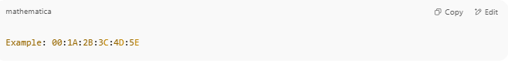
Example: 00:1A:2B:3C:4D:5E

- First 3 bytes: Manufacturer ID (e.g., Intel, Cisco)
- Last 3 bytes: Device ID (assigned by manufacturer)

🛠 Where It’s Used:
# Source: Chatgpt (GPT‑5 Mini) at [12/18/2025]
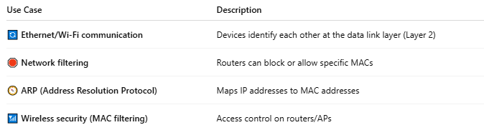

Use Case | Description
🔄 Ethernet/Wi-Fi communication | Devices identify each other at the data link layer (Layer 2)
🛑 Network filtering | Routers can block or allow specific MACs
🧭 ARP (Address Resolution Protocol) | Maps IP addresses to MAC addresses
📶 Wireless security (MAC filtering) | Access control on routers/APs

📡 MAC vs IP Address
# Source: Chatgpt (GPT‑5 Mini) at [12/18/2025]
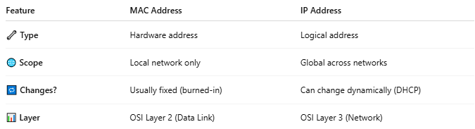

Feature | MAC Address | IP Address
🔧 Type | Hardware address | Logical address
🌐 Scope | Local network only | Global across networks
🔁 Changes? | Usually fixed (burned-in) | Can change dynamically (DHCP)
📊 Layer | OSI Layer 2 (Data Link) | OSI Layer 3 (Network)

🔍 How to Find Your MAC Address
# Source: Chatgpt (GPT‑5 Mini) at [12/18/2025]
- 🪟 Windows:
Open Command Prompt → type: ipconfig /all
Look for Physical Address
- 🍏 macOS/Linux:
Use command: ifconfig or ip link
- 📱 Mobile:
Go to Wi-Fi settings → tap your network → look for MAC address

🛡 MAC Address Spoofing
# Source: Chatgpt (GPT‑5 Mini) at [12/18/2025]
Some software lets users change (spoof) their MAC address:
- For privacy
- To bypass MAC filtering
- For testing purposes

📌 Summary
# Source: Chatgpt (GPT‑5 Mini) at [12/18/2025]
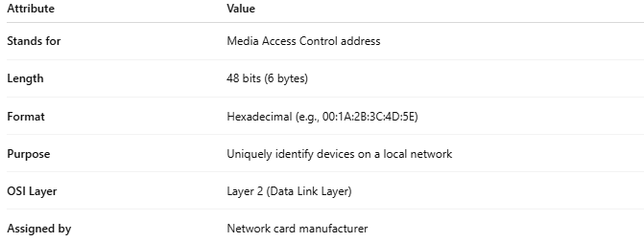
Attribute | Value
Stands for | Media Access Control address
Length | 48 bits (6 bytes)
Format | Hexadecimal (e.g., 00:1A:2B:3C:4D:5E)
Purpose | Uniquely identify devices on a local network
OSI Layer | Layer 2 (Data Link Layer)
Assigned by | Network card manufacturer

